**A team of various web professionals working on a website redesign.**

1. **Scrum Roles**
2. **Product Owner**

* Build and manage the product backlog.
* Give the team clear guidance on which features to deliver next.
* Product owners focus on ensuring the development team delivers the most value to the business.
* Product owner balances the need of other stakeholders in the organization.

**Product Owner Responsibilities**

Managing the scrum backlog

Release Management

Stakeholder Management

Collaborate with users, consumers, governance, organization leadership.

1. **Scrum Master**

* Scrum masters are the champions of scrum within their teams.
* They coach teams, product owners, and the business on the scrum process, and look for ways to fine-tune their practice of it.
* Scrum master deeply understands the work being done by the team.
* Assist with self-organization, outcome focus, reaching a “done increment”, and managing roadblocks.
* In sprint planning scrum master supports product owner.

**Scrum Master Responsibilities**

Transparency

Self-organization

Protecting the team

Empiricism

Scrum values

Remove blockers

1. **Members of Development Team**

* The folks that work here make up the development team.
* Team members have differing skill sets, and cross-train each other
* Self-organization
* Design
* Development
* UX
* Testing
* Delivery

**Responsibilities**

Delivering work throughout the sprint.

In charge of running scrum meeting

Maintain balance of tasks

**Activities of Scrum**

1. **Sprint planning meeting – 2 – 4 weeks**
2. **Daily standup**
3. **Sprint Reviews**
4. **Sprint Retrospective**

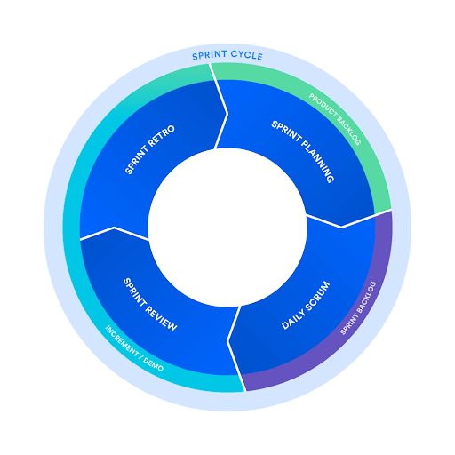

**Who Attend What Meeting in Scrum**

|  |  |  |  |
| --- | --- | --- | --- |
| **Event** | **Product Owner** | **Scrum Master** | **Developer Team** |
| **Sprint Planning, I** | Yes | Yes | Yes |
| **Sprint Planning II** | Yes | Yes | Yes |
| **Sprint Planning III** | Yes | Yes | Yes |
| **Sprint Planning IV** | Yes | Yes | Yes |
| **Daily Meeting** | NO | Optional | Yes |
| **Sprint Review** | Yes | Yes | Yes |
| **Sprint Retrospective** | Yes | Yes | Yes |
| **Product Retrospective** | Yes | Yes | Yes |

**Sprint** Scrum projects are broken down into small and consistent-time intervals referred to as sprint.

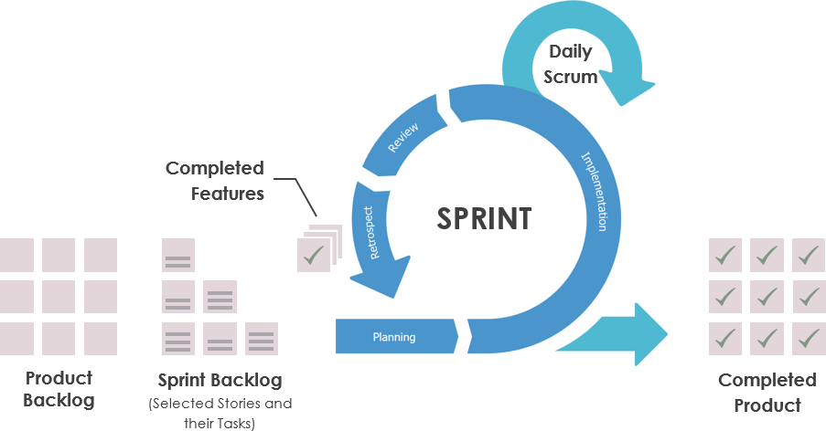

1. **Sprint planning meeting**

Conducted before the start of a sprint.

**Purpose** –**.** Set a Sprint Goal and create sprint backlog.

**Sprint Goal Template**

* Actual goal.
* Method employed to reach the goal.
* Metrics to determine if the goal has been met.

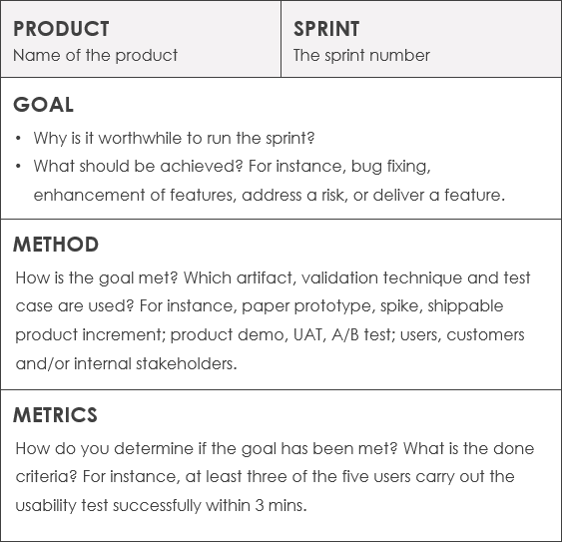

**Product Backlog**

* The Product Backlog lists all the features, use cases, user stories, improvements, and bug fixes that are made to future releases.
* Each entry having a unique order.
* Product to-do list entries at the top need to be developed immediately.

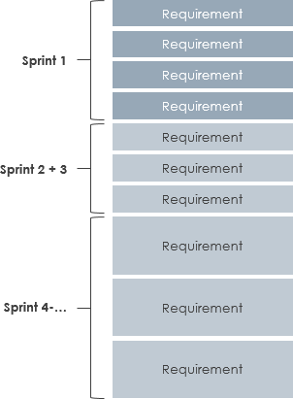

**Sprint 1 -** Product Owner presents the highest priorities of the Product Backlog to the team.

**Sprint 2 -** The team commits to this Product Backlog

**Sprint 3 -** The team plans how it will meet this commitment by detailing its work as a plan in the Sprint Backlog.

**Sprint 4 -** Detail planning.

**Sprint Backlog**

* A list of all things that needs to be done within the project.
* Sprint Backlog is the development team’s expectation of what functions will be included in the next increment and what work will be required to deliver those functions.
* The Sprint Backlog is a sufficiently specific plan to make progress changes understandable in daily meetings.

**Product Increment**

* The sum of all the Product Backlog items completed during a Sprint and the value of the increments of all previous Sprints.
* A product Increment is the “goal line” for each sprint.

1. **Daily Scrum Meeting**

* It is a 15-minute event for the Development Team to synchronize activities and create a plan for the next 24 hours.
* It keeps distracting chatter to a daily meeting, so the team can focus on the work for the rest of the day.
* Ensure everyone within the scrum team is on the same page, have a shared understanding of tasks and goals.
* **Participants:**
  + Scrum master
  + Team members
  + Optional: Product owner, other stakeholders
* **Duration**: 15 minutes

**Agenda**

* Focus on the 3 questions:
  + What did I do yesterday?
  + What will I do today?
  + Are there any obstacles?

1. **Sprint Reviews**

* At the end of the sprint, the team gets together for an informal session to view a demo of the increment.
* The development team showcases items to stakeholders and teammates for feedback.
* The product owner can decide whether or not to release the increment.
* The scrum team will ask customers to review whether the work demonstrated meets the definition of done at this point and adapt the Product Backlog if needed.
* For a one-month sprint, consider sprint review to a maximum of four hours.

1. **Sprint Retrospective**

* An event for providing an opportunity for the Scrum Team to inspect itself and create a plan for improvements to be enacted during the next Sprint.

1. **Steps for Conducting Sprint Retrospective Meeting**
2. **Set the stage** – Set the goal.
3. **Gather data** – Help everyone remember; Create a shared pool of information
4. **Generate insight** – Why did things happen the way they did? Identify patterns.
5. **Decide what to do** – Pick a few issues to work on and create concrete action plans.
6. **Close the retrospective**– Clarify follow-up; Appreciations; Clear end; How could the retrospectives improve?

* This is at most a three-hour meeting for one-month Sprints.
* The Scrum retrospective meeting can be thought of as a “lessons learned” meeting. Right Retrospective questions allow the team to think, at the same time provides an ownership to each team member thus making it truly Agile.

**Time Duration in The Scrum**

**Sprint Planning -** 8 hours for a one-month Sprint.

**Daily Scrum**: The Daily Scrum is a timebox of 15 minutes.

**Sprint Review**: The Sprint Review is a timebox of four hours or less for one-month Sprints.

**Sprint Retrospectives**: The Sprint Retrospective is a timebox of three hours for a one month sprint.

**Sprint**: The Sprint is a timebox of one month in which the scrum team will deliver the Sprint goals.

**NOTE**

The scrum framework guides the creation of a product, focusing on value and high visibility of progress. Working from a dynamic list of the most valuable things to do, a scrum team brings that product from an idea to life using the scrum framework as a way to encourage transparency, inspection, and adaptation.